Orchard Acres Complex

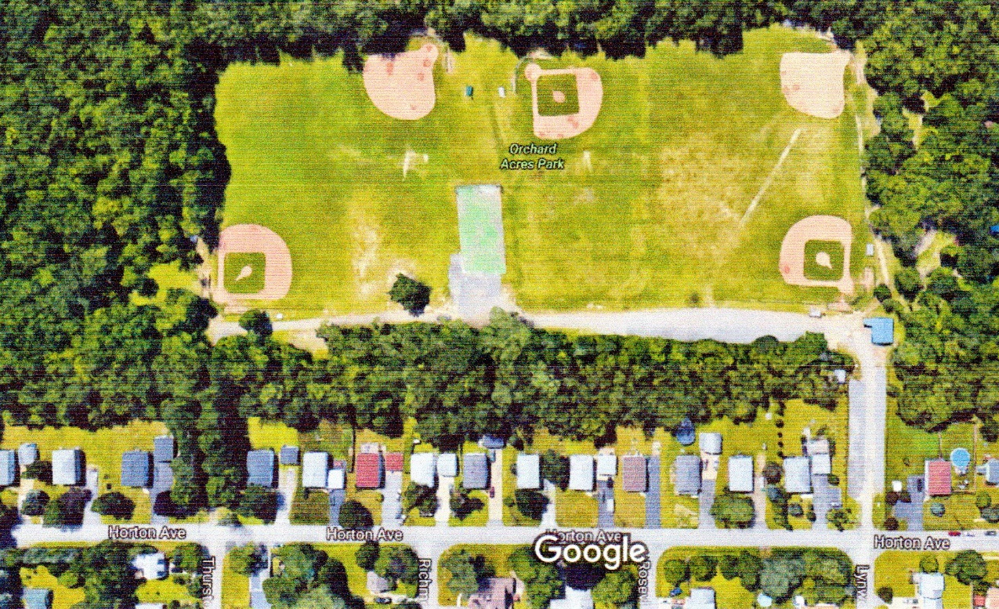
#5
Check in / Snack Shack
#1
#3
#2
EXIT
Enter

